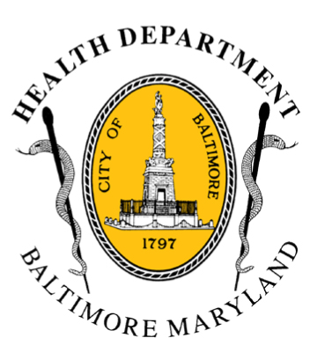
BCHD PRESS RELEASE
Baltimore City Health Department
1001 E. Fayette Street • Baltimore, Maryland 21202
Stephanie Rawlings-Blake, Mayor
Leana Wen, M.D., Commissioner of Health

FOR IMMEDIATE RELEASE
July 28, 2015

Media Contact:
Jennifer Fuson
O: (410) 545-0823
E: Jen.Fuson@baltimorecity.gov

BCHD Encourages Everyone to Get Vaccinated, Screened on World Hepatitis Day

Baltimore Sees High Rates of Hepatitis C in City’s STD Clinic Population

BALTIMORE, MD (July 28, 2015) – As today marks “World Hepatitis Day,” Baltimore City Health Commissioner Dr. Leana Wen encourages residents to get vaccinated for hepatitis B (HBV) and screened for hepatitis C (HCV). Both hepatitis B and C are viruses that can lead to serious health issues, like liver cancer and liver failure. An estimated 12,000 Americans die from hepatitis C complications each year, and between 3,000 and 4,000 people die from hepatitis B annually. Hepatitis C virus is a silent epidemic, fueled by under-diagnosis and under-treatment. In addition, HCV is the leading cause of liver transplants each year.

“Hepatitis is a phantom killer, as someone can have it for decades without symptoms until it’s too late,” said Dr. Wen. “The good news is that there are new pills that makes it possible to cure HCV with a 12 week course of therapy with minimal to no side effects—but patients have to be tested to know they have the disease.”

In 2013, when free hepatitis C screenings began in Baltimore’s STD clinics, high rates of HCV (7%) were found among the clinic population. One in three clinic clients born between 1945 and 1965 was HCV infected. Testing is performed at the city’s two clinics located at 620 N. Caroline Street and 1515 W. North Avenue.

National estimates are that 2.7 million people, about 1% of all Americans, are infected with HCV. Over 75% of these infections are in individuals born between 1945 and 1965. In 2012, the CDC made recommendations for HCV testing at least once in their lifetime for all individuals born during these years.

There is no vaccine for HCV, but there is for HBV, which is transmitted through blood, semen, or another body fluid from a person infected with the hepatitis B.

A twelve week course of treatment for HCV can be over $90,000, limiting access to treatment. Insurance programs including Medicaid will cover drug costs for some patients, and there are patient assistance programs available to aid access to HCV drugs for uninsured patients.

In 2014, the Baltimore City Health Department, in collaboration with the Maryland Department of Health and Mental Hygiene, the Johns Hopkins University School of Medicine, and the Baltimore County Health Department, received a multi-year grant from the Centers for Disease Control and Prevention to launch a regional initiative to expand HCV testing and treatment.

The grant provides support for STD clinics to expand services to include HCV treatment to all patients in June 2015. Individuals diagnosed with HCV at the STD clinics receive initial comprehensive care including medical education, alcohol counselling, and referral to HCV treating specialists and case management support to aid access to HCV drug therapy. About 50% of HCV-infected individuals identified at the STD clinics have been linked to a specialist of HCV care.

An established national leader in the public health community, Baltimore’s HCV program was recognized at the White House World Hepatitis Day celebration in 2013 as a program successfully addressing HCV in the United States.

# # #

